French 1a  room 0108  Instructor: Madame Teefy  Master of French, Master of Education  patricia.teefy@spps.org  tel: 651-293-8860 | This is an IB-MYP (International Baccalaureate Middle Years Programme) course, which values communication, holistic learning, and intercultural awareness.  At the beginning of the year, I CAN….  - use single words and phrases that I have practiced & memorized  - recognize familiar words about certain topics when I hear or read them¨ supported by gestures or visuals in fictional texts  At the end of the year, I CAN….  - communicate on very familiar topics using a variety of words and phrases that I have practiced & memorized  - present basic information on familiar topics using language I have practiced using phrases and simple sentences understand familiar words, phrases, and sentences within short and simple texts related to everyday life  - usually understand the main idea of what I have read  - identify cultural products & practices to help me understand perspectives  World-Readiness Course Objectives  - COMMUNICATE  - LEARN ABOUT & UNDERSTAND DIVERSE CULTURES  - CONNECT WITH OTHER DISCIPLINES. GET CAREER-READY.  - COMPARE & REFLECT LANGUAGES & CULTURES  - COLLABORATE & INTERACT WITH MULTI-LINGUAL COMMUNITIES.
This Photo by Unknown Author is licensed under CC BY-SA

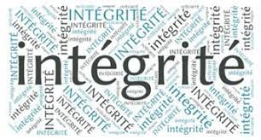
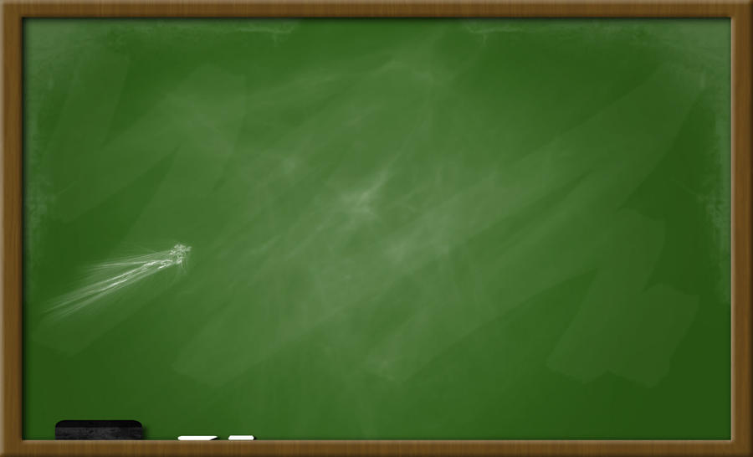
Class Learning Expectations
- We are RESPECTFUL (of oneself, peers, teacher, and surroundings).
- We are RESPONSIBLE (on time, organized, questioning).
- We are READY (prepared, focused).
- Keep cell phones AWAY during class.
- If / when you are absent, check SCHOOLOGY – this is where your work will be.
CLASS MATERIALS
- TEXTBOOK: T’es branché 1 (electronic copy on Clever
- I-pad – fully charged (bring charger to class)
- Notebook with pockets for handouts OR three-ring binder, lined paper/pockets. FRENCH ONLY
- Earbuds or headphones
- Pencils, pens
- Keep cell phones away during class
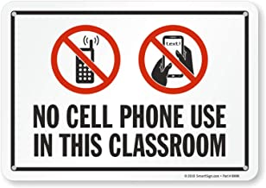

Grading
MYP Levels of Achievement: Hidden River is an IB-MYP (International Baccalaureate Middle Years Programme) school.
You will have many opportunities to show you’re learning: individual & group projects, presentations, skits, discussions, and oral interviews. Have fun & be creative. Feel free to make suggestions too. For example, if I assign a brochure on a particular topic and you prefer to create a digital presentation, ask!

To view student progress in class, please CLICK HERE TO GO FOR INFORMATION ON ONESTOP
and sign in with your g# and password. As a parent account holder, you can see your student’s grades submissions etc.
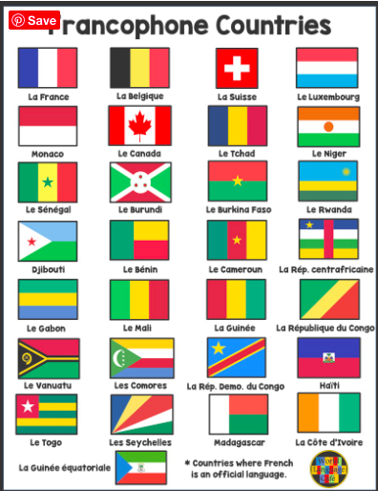
Password problems or reset issues? Contact tech help at school or click here.

Each semester grade will be calculated using the following formula:

SUMMATIVE
- Projects and other types of assessments (quizzes, tests, oral presentations, etc.). All assessments will be announced in advance, so be sure to review the material.
FORMATIVE
- Ongoing checks of work, smaller assessments, everyday assignments, different activities are all used to inform how students are progressing within the unit of study. Homework is part of the formative assessment category.

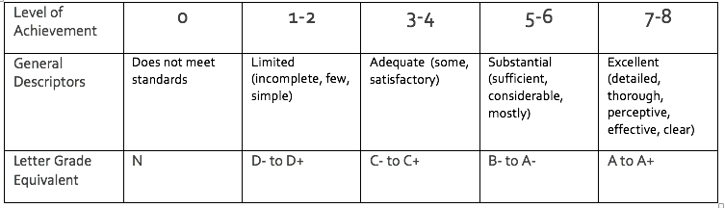
IB-MYP grading
Teachers sometime assign tasks to check student understanding, usually warm-ups or exit tickets, that are graded for completion: 2 points=complete, 1 point=partially complete, and 0 points=missing. For more detailed feedback, teachers will use the IB achievement levels (0-8).

IB teachers assess work using content-specific rubrics to determine students’ current level of achievement​ as students demonstrate their abilities in terms of the four objectives. These levels will be reported in Schoology. However, as a school district we still use traditional letter grades, so we use the following scale to interpret the IB scores and transfer them to letter grade.

All the summative assessments will be given a level of achievement. These levels are: 0 does not meet standards, 1-2 limited, 3-4 adequate, 5-6 substantial, or 7-8 excellent. These levels will be reflected in Schoology and are meant to show improvement throughout the year.

Check your grades regularly on Schoology.
This Photo by Unknown Author is licensed under CC BY

French Hidden River Middle School
Allons-y! Amusons-nous! Parlons français!

TO DO:
- READ THE SYLLABUS
- HAVE YOUR PARENTS/GUARDIANS READ THE SYLLABUS
- BOTH YOU AND YOUR PARENTS SIGN AND RETURN THIS SHEET ONLY
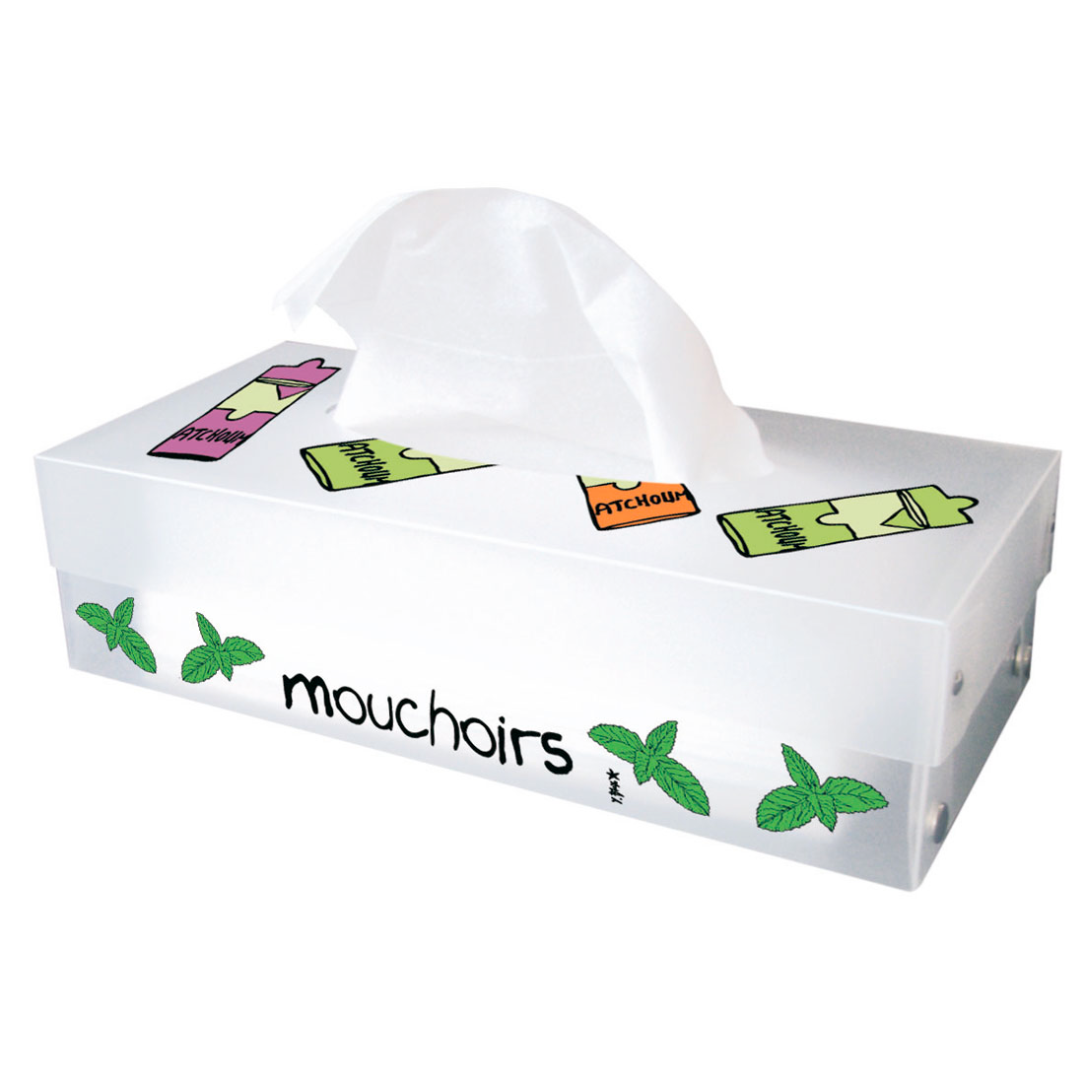

Donation
Cooking and other activities are an integral part of French class. In order to do more of these enriching activities, I invite you to make a $10.00 donation (or any amount) for the purchase of food and other materials in French class. If possible, please include your $10.00 donation with the signed form below.
____________________________________________________________________________________________________
French Hidden River Middle School
Allons-y! Amusons-nous! Parlons français!

**I have read, understand, and will abide by the expectations and rules for French class.

________________________________ ________________________________
Student Name (print) Student Name (signature)

**We have read, understand, and will support our student in abiding by the expectations and rules for French class.

________________________________ ________________________________
Parent/Guardian Name (print) Parent/Guardian Name (signature)

Parent/Guardian email address: _________________________________________________

